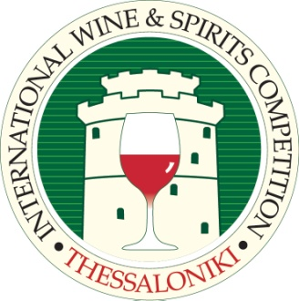

We would like to thank you for participating at the Thessaloniki International Spirits Competition and to congratulate you on your awarded medal.

Stickers that correspond to the awarded medals are available for purchase. For your orders please complete the purchase form on the next page and send it to us by e-mail (director@wineroads.gr) or by fax at the following number: +30 2310 281619.

Sticker prices are as follows:

Quantity | Price
1-50.000 | 32,25 € / 1.000 stickers
More than 50.000 | 25,8 € / 1.000 stickers

Payment can be accepted by bank transfer to the following bank accounts (please email or fax us a copy of the transfer order):

Alpha Bank - Account No: IBAN GR91 0140 7410 7410 0200 2000 210
BIC: CRBAGRAA

Piraeus Bank – Account No: IBAN: GR85 0172 2020 0052 020 14279954
BIC: PIRBGRAA

National Bank of Greece – Account No: IBAN GR10 0110 2100 0000 2102 0675 522,
BIC: ETHNGRAA

Please do not hesitate to contact us for any enquiries (director@wineroads.gr or +302310 281617, +302310 281632).

Thessaloniki International Spirits Competition
Promotional Stickers Order Form
Please return your completed form to: Fax: +30 2310 281619/
Email: director@wineroads.gr

Name
Company
Delivery Address
Telephone
Email

Please send me (by courier service, recipient’s charge) the following number of bottle stickers:

 | Gold Medal  * immediate sending if there is a stock | Silver Medal  * immediate sending if there is a stock | Bronze Medal  * immediate sending if there is a stock | Best of Competition  * send on request, within 15 business days
Quantity
(x 1000)
The volume (ml) of the bottles that the stickers will be placed on
Spirit name and
production year

I made the payment to the following Bank:

Alpha Bank
Piraeus Bank
National Bank of Greece

Date: Signature:

